Quantel/Aviso RF Frame Grab Software

v. 2.0 prepared by Jeff Ketterling (10/1/2017)

Purpose

The program “QuantelDataGrab.vi or exe” [*.exe is run time version, *.vi is the code that can be modified in LabVIEW] is used to acquire the RF data from a modified Quantel Aviso unit. A shortcut should be on the desktop. A single BNC cable is the only connection between the control PC and the Aviso unit. The BNC cable connects to the high- or low-frequency port, depending on the Quantel probe being used.

Initial Setup

The control PC comes preinstalled with all the necessary software already in place. The software is activated from a desktop shortcut with the “QuantelDataGrab.***” name.

The connections prior to use are shown below. The pre-amp module has a power supply and needs to plugged in. Raw10 is generally for posterior probes and RawHF for anterior.

PC

“Input” of digitizer

Aviso RawHF or Raw10 BNC Port

Pre-amp module

Input Output Aviso to PC

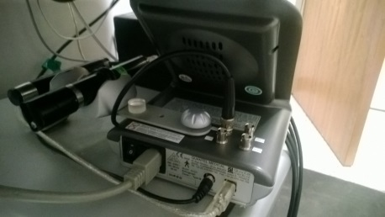 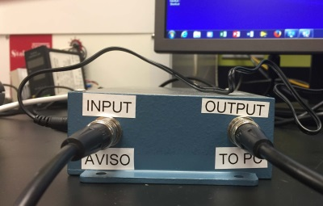 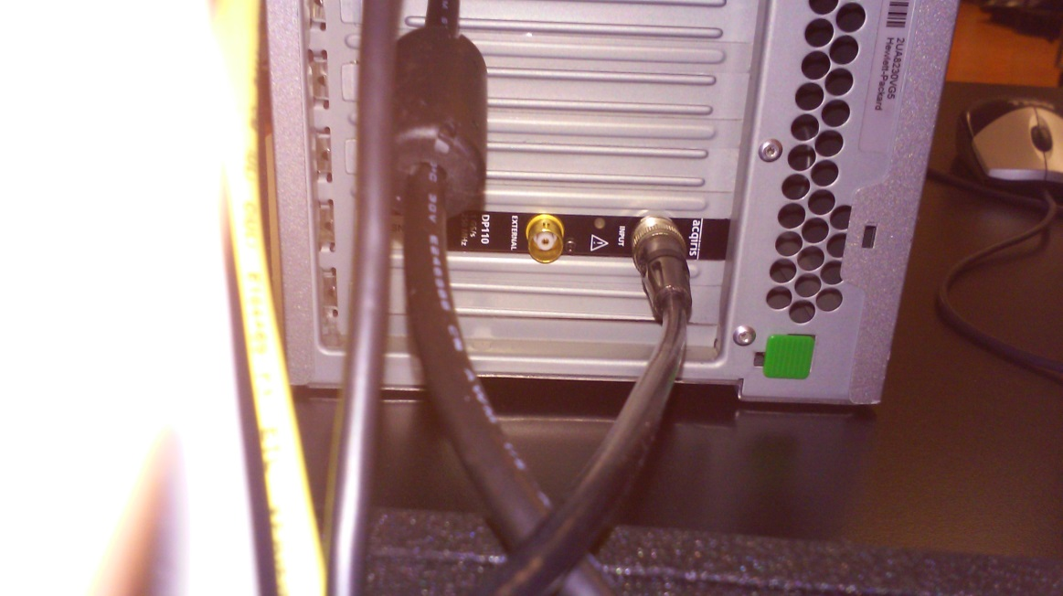

**PC Digitizer**

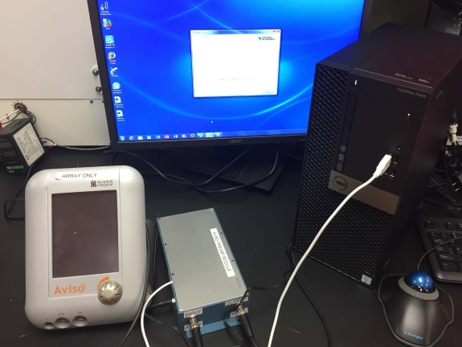

The amplifier box has two power inputs. One is a USB cable and one is 12V that plugs into the wall.

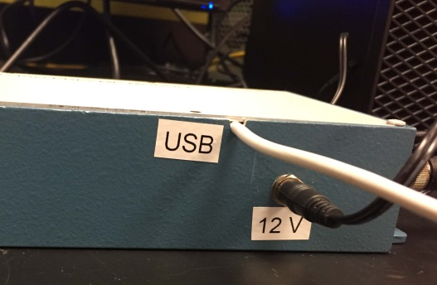

Filters are provided to improve the signal-to-noise of image. There is a low pass and a high pass filter. They should be inserted between the PC and amplifier box (bottom right corner of image).

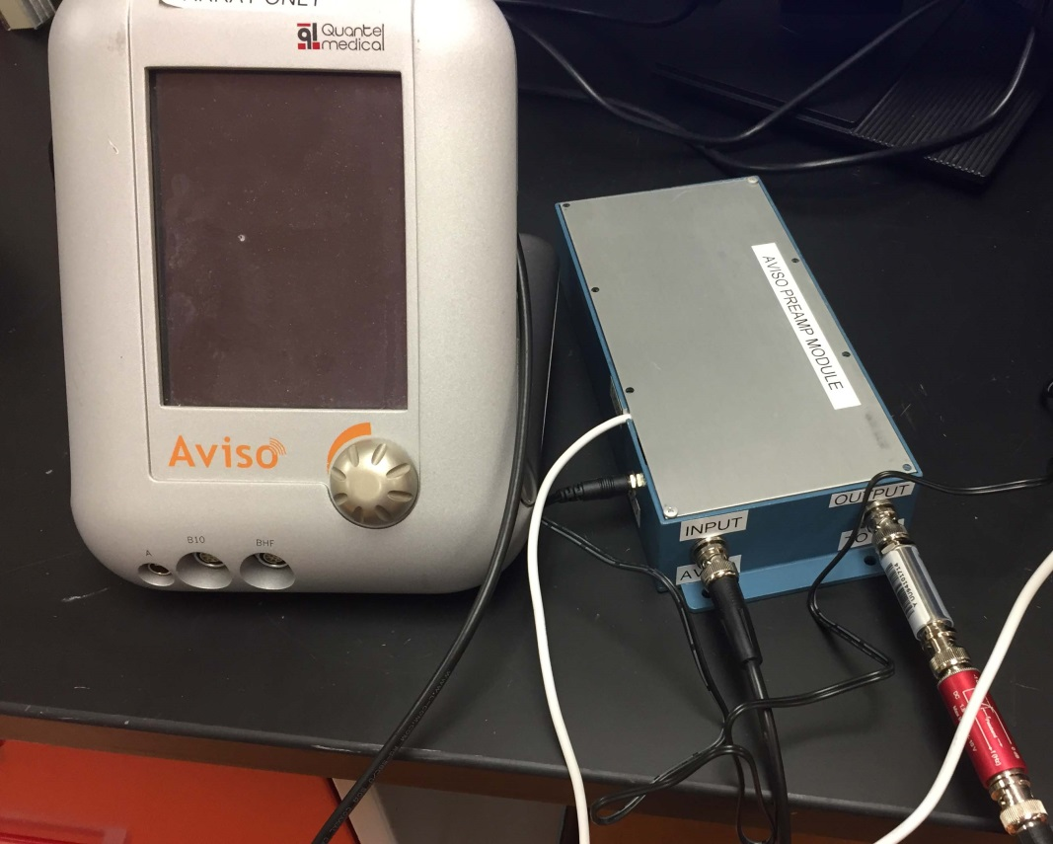

Using Software

1. Double click “QuantelDataGrab.vi or EXE”. A window will open and the software will run upon opening. The software is running with the right-pointing arrow is black (circled in red below). If for some reason the software is stopped, pressing the array so it turns black means the software is running again.

If the Aviso probe is scanning, the pre-amp box is plugged in and the correct cable connections are made between PC and Aviso, then ultrasound images will appear in the region in the yellow box. A red light in the area with the purple circle means that no data is available to capture.

Pressing the “Stop” button (green box) will stop the program running. It can be restarted by pushing the array in the upper left corner (red circle).

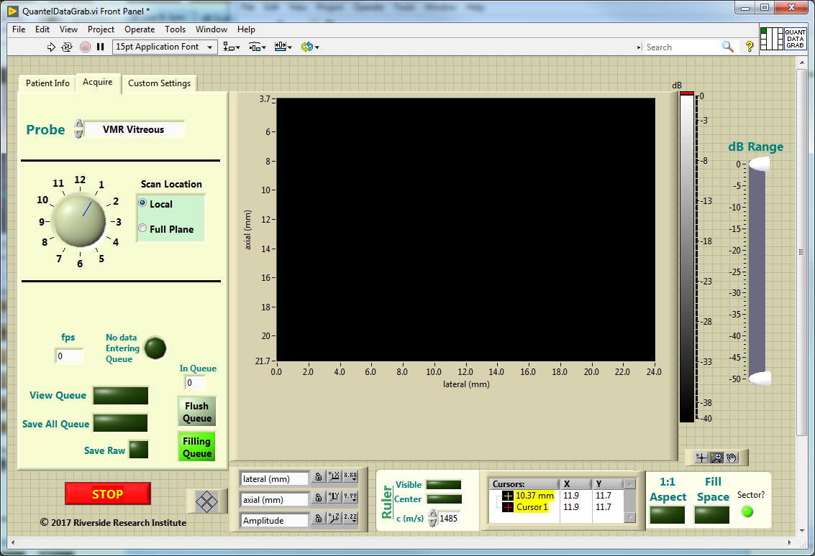

2. The first time the software is executed or any time the Patient Info button is selected, this window will pop up. This provides some basic patient info to be entered as well as some notes. Saved data files will get saved in a folder named “Last Name”,”FirstInitial”_Year_Month_Day. The saved data will be in the D: drive. (Possibly another partition but still in Temp folder.)

The file names will have a format “PatientID”_ ”OD or OS”_[A-Z]_[000-999].***

The *** will be a raw *.eye file format and a jpg or bmp.

Press “Exit” to go back to main program (Circled in red). A first name, last name and patientID must be entered or the patient info window will not close.

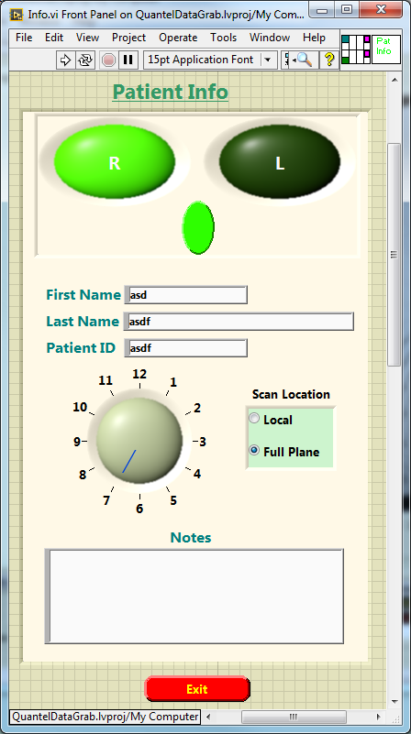

3. Most of the available controls have some help information to help guide the user. To see the help feature, select the Show Context Help. A context help will open and hovering over a control will provide information about that control and how do use it.

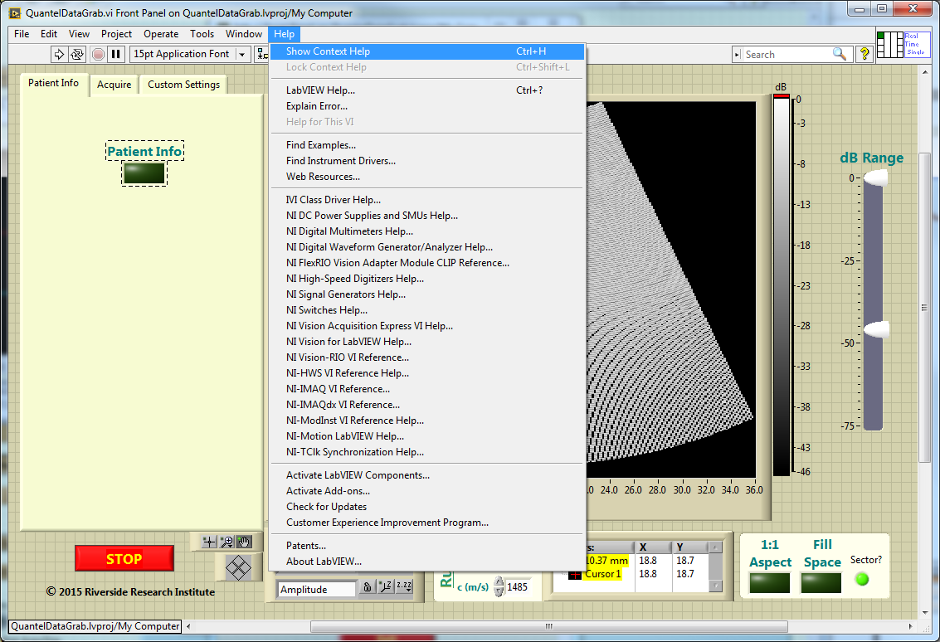

4. The probe pull down menu chooses parameters based on the probe being used (red circle). Be sure to use correct BNC cable connection to the Aviso based on whether a high or low frequency probe is used.

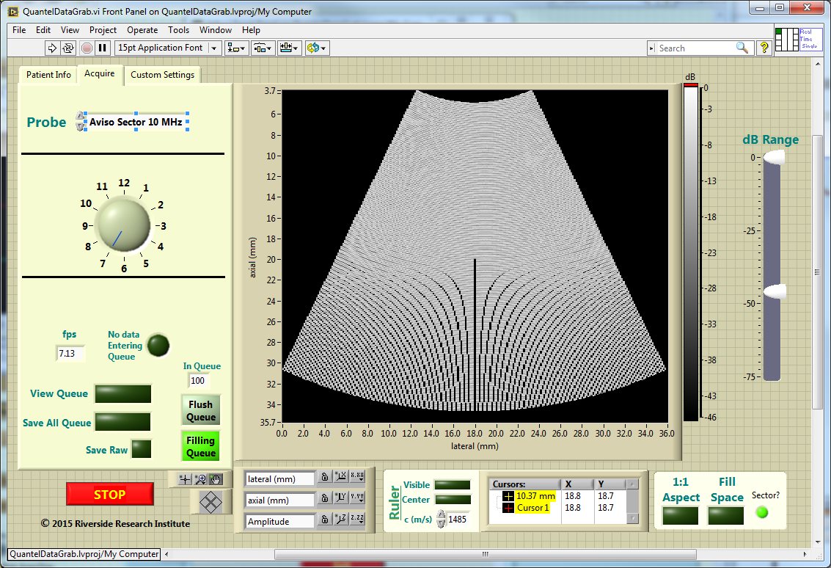

5. Data is saved by selecting one of the buttons in the yellow box. The options are to save the last 100 images (Save All Queue), open a viewer and choose the upper and lower range of images to save from the queue (View Queue), or to save a continuous stream of data (Save Raw).

The queue can be flushed or filling can be halted with the options in the blue box.

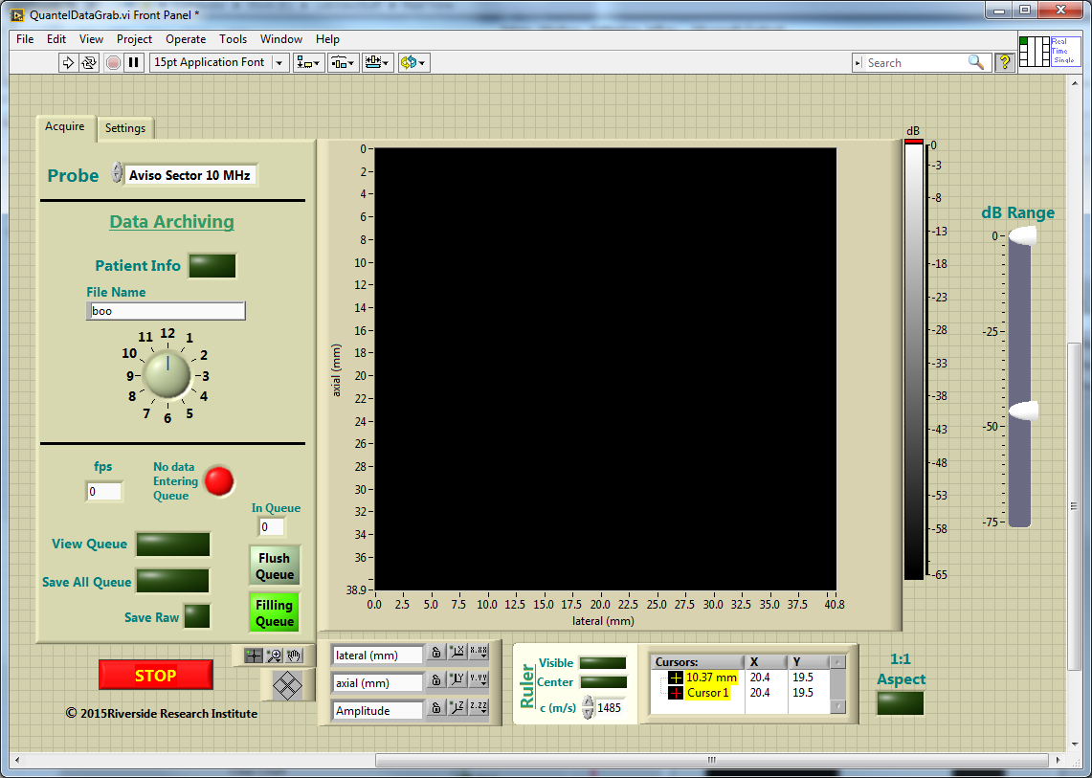

6. There are a bunch of custom settings in the Settings tab but these should not generally be used! However, in custom mode from the Acquire menu, the settings related to the displayed image can be adjusted and a new probe profile can be saved.

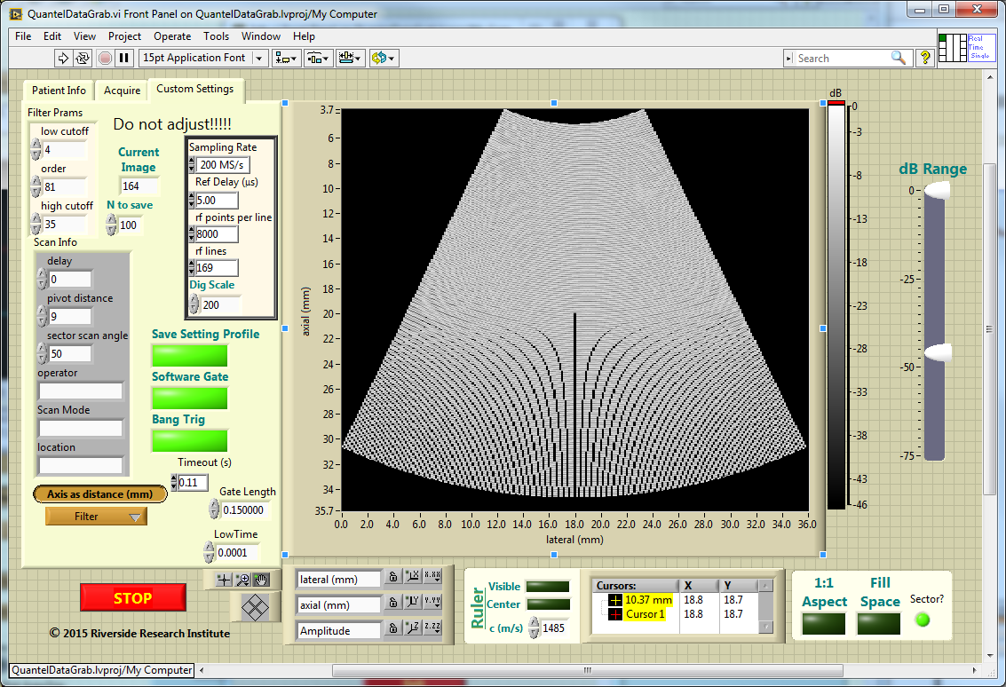

**Notes:**

The inside of the amplifier box is below. The Aviso connects to a buffer amplifier, the buffer amplifier connects to a preamplifier, and the preamp connects to the PC.

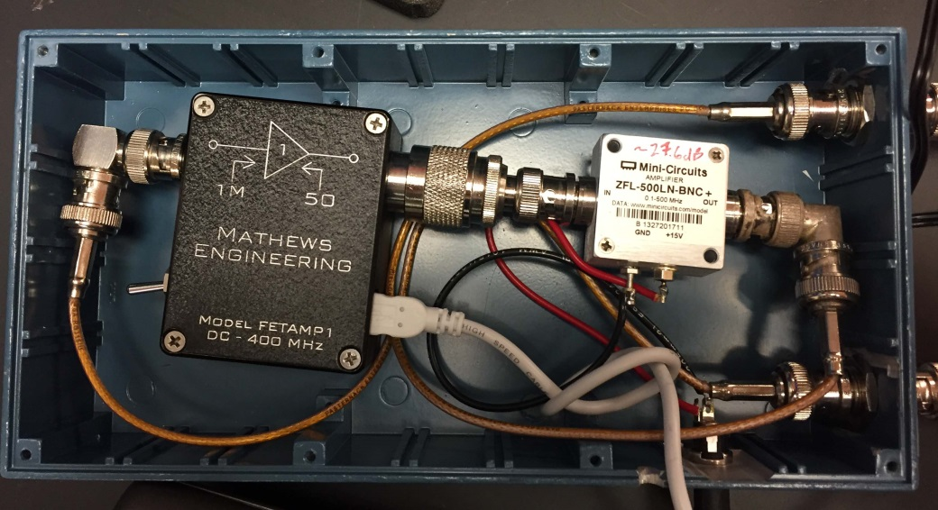

If for some reason the signal from the amplifier box is giving very poor images on the computer screen. It may be necessary to remove the buffer amplifier as pictured.

